来华留学生监护人保证书
Guardian`s Letter of guarantee

本人愿意作为 NIGERIA （学生国籍）留学生 JOHN VICTOR CHUKWUEBUKA_
（学生姓名）在沈阳城市学院学习期间的监护人，并担保如下事项：
I am willing to be the guardian for the JOHN VICTOR CHUKWUEBUKA_
(full name) from NIGERIA (Nationality) during the student’s study in Shenyang City University in China the following terms:
一、监督该生不从事来华学习目的以外的活动并遵守中国的法律；
1.To supervise the student to make sure that he/she abides by the Chinese laws and does not do any illegal activities which have nothing to do with the student’s study.
二、督促该生努力学习并遵守学校的各项规章制度；
2.To supervise the student to study hard and observe all rules and regulations of the university.
三、负责该生在校学习期间发生疾病和其他意外事故的处理工作；
3.To be responsible to handle the student’s illness and other accidents during the study at LNTU.
四、监督该生按时交纳各项费用。
4.To supervise the student to pay all expenses on time.
监护人姓名  Guardian’s Name | ANDREW KANENE OMEILE | 护照号码  Passport or ID No. | A11712910
与被监护人关系  Relation to the student | UNCLE | 国籍  Nationality | NIGERIA
中国电话  Tel No.（in China ） | 13093733768 | 工作单位  Workplace | IKESON TEXTILES  COMPANY HANGZHOU
通讯地址  Address | ROOM 801-014 LIXIN BUILDING 102 MOGANSHAN ROAD GONGSHU DISTRICT HANGZHOU CITY ZHEJIANG

监护人签名Guardian’s Signature: ANDREW KANENE OMEILE

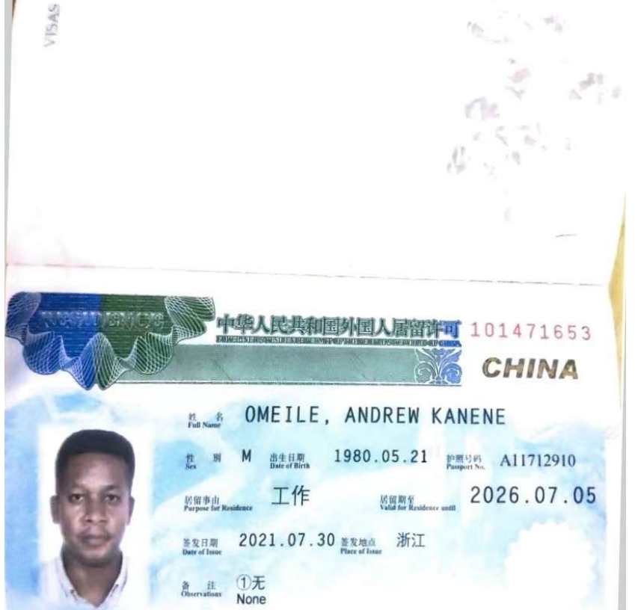
27/11/2025
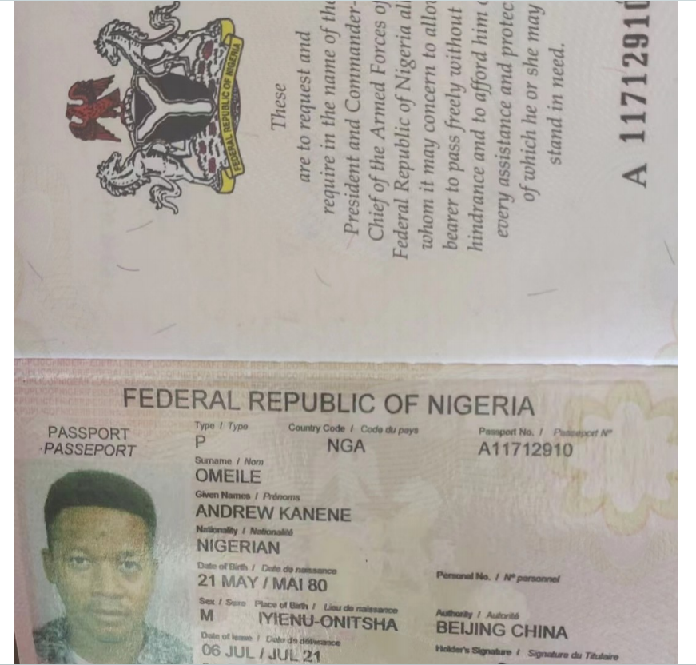
DD/MM/YYYY

