禁毒承诺书Anti-Drug Commitment

护照姓名 Passport Name：
性别 Gender：
国籍 Nationality：
出生日期 Birth Date：
本人郑重承诺：至今，在本国及境外无任何涉毒记录。 在中国留 学期间遵守中国法律，保证不从事贩毒、吸毒等一切违法活动。不结 交吸毒、贩毒的人。
以上承诺如有不实，本人愿承担一切法律责任。

I solemnly promise that I have no drug-related record both at my home country and abroad. I obey Chinese laws while studying in China, and ensure that Ido not engage in illegal activities such as drug trafficking,drug abuse. Ido not make contact with people who use drugs or drug trafficking.

I here by declare that the above statement is true, correct and complete,for which I shall bear all the legal responsibility.

申请人本人签字 Signature：
承诺日期 Date：

中国有关禁毒的法律法规
Chinese Relevant Law and regulationson Drug Control

《中华人民共和国刑法》第三百五十七条规定:毒品是指鸦片、海洛因、甲基苯丙胺(冰毒)、吗啡、大麻、可卡因以及国家规定管制的其他能够使人形成瘾癖的麻醉药品和精神药品。

According to the relevant provision of Article 357 of the Criminal Law Of the People's Republic of China: The term "narcotic drugs" as used in this Law means opium,heroin,methylaniline(ice),morphine,marijuana, cocaine and other narcotic and psychotropic substances that can make people addicted to their use and are controlled under State regulations.

《中华人民共和国治安管理处罚法》第七十二条规定:对于吸食、注射毒品的，处十日以上十五日以下拘留，可并处二千元以下罚款;情节较轻的，处五日以下拘留或者五百元以下罚款。

According to the relevant provision of Article 357 of the Criminal Law Of the People's Republic of China: The term "narcotic drugs" as used in this Law means opium,heroin,methylaniline(ice),morphine,marijuana, cocaine and other narcotic and psychotropic substances that can make people addicted to their use and are controlled under State regulations.

《中华人民共和国禁毒法》第三十二条规定:公安机关可以对涉嫌吸毒的人员进行必要的检测，被检测人员应当予以配合;对拒绝接受检测的，经县级以上人民政府公安机关或者其派出机构负责人批准，可以强制检测。

According to the relevant provision of Article 32 of Narcotics Control Law of the People's Republic of China: The public security organ may make necessary testing on drug addict suspects, and such suspects shall accept the testing; if anyone refuses to accept the testing, a compulsory testing on him is allowed upon the approval of the person in charge of the public security organ of the people's government at or above the county level or its dispatched office.

如何区分毒品
How to identify drugs
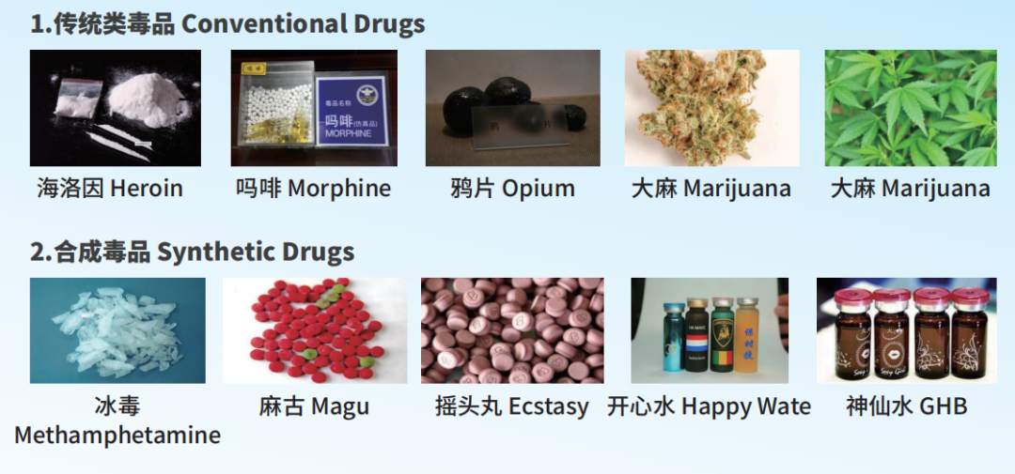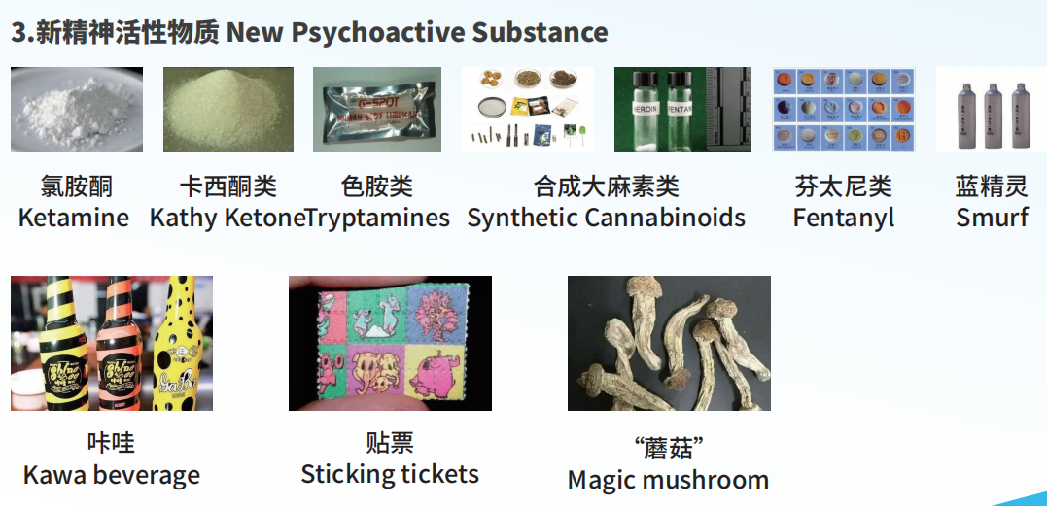

吸毒处罚
Punishment for drug abuse
罚款 / 拘留
Fine / arrest
限期离境
Leave the country within the prescribed period
开除学籍
Expulsion from school
涉毒最高死刑
Maximum death penalty for drug-related!
义乌工商职业技术学院对于毒品零容忍！
YWICC has zero drug tolerance！

